KadeeStudio — Architecture & Implementation Plan
Oct 31, 2026 · @Duggie

Vision and scope
KadeeStudio is one native Rust desktop suite, with a self-hosted collaboration server, that replaces separate tools for Markdown, PDF, conversion, dashboards and reports, and hosts the ArtCraft Crafting Apps. The first deliverable is only the start screen: a shell with module cards, recent files and settings, no editors and no AI. AI follows in Phase 1, before the editors.
Module | Replaces | First release
Kadee AI | Separate chat tools; one assistant that works across every module and file | Phase 1
Kadee Markdown | Typora, MarkText, Word for plain-text docs | Phase 2
Kadee PDF | Acrobat (view, annotate, organise, sign) | Phase 4
Kadee Convert | Pandoc-style converters, online PDF tools (reached from File › Convert and the right-click menu; no start-screen tile) | Phase 5
Kadee Dashboards | Metabase, Power BI dashboards | Phase 6
Kadee Reports | Power BI paginated reports, Crystal-style reports | Phase 6
Crafting Apps | CadCraft, DeckCraft, DesignCraft, EffectCraft, FigCraft, FilmCraft, GridCraft, LightCraft, PdfCraft, PhotoCraft, SolidCraft, SoundCraft, VectorCraft and WordCraft, launched or embedded | Phase 7
Design principles:
- Native Rust end to end. No Electron, no JavaScript in the app shell; one codebase for macOS, Windows and Linux, with a WASM build later.
- Everything is a command. Every button, shortcut and menu item calls a command with an id (file.new.markdown, home.open), as in mdcraft and the Crafting Apps. This is what lets the Phase 1 AI drive every action, and later the CLI and MCP too.
- Local-first, collaborative by default. Documents are CRDTs that work offline and sync to a KadeeStudio server on-prem or in the cloud.
- Modules are crates. The shell knows modules only through a small trait, so each editor can be built, tested and shipped on its own.
- Open formats. Markdown stays plain Markdown, PDF stays PDF, dashboards are stored as readable JSON/YAML definitions.

What we reuse
KadeeStudio borrows its shell layout from GenOffice, its Markdown engine from mdcraft, its collaboration stack from SolarOffice, and its native UI style and engines from the ArtCraft Crafting Apps.
Source | What it is | What KadeeStudio takes
mdcraft | Your Rust Markdown word processor: tao + wry webview, CodeMirror editor, comrak renderer (MarkDown Live) with Mermaid, KaTeX, charts, slides, 11 document and 8 deck templates, CLI and MCP server | mdcraft-core renderer and templates as library crates; the ribbon layout, File view and command ids; its MCP server as a model for the AI tools
SolarOffice | Your earlier Rust suite: Dioxus 0.7 + Tailwind, home screen with tab strip, sidebar (Recent, Starred, folders), quick-start cards, sortable file list; an AI layer (solar-ai: providers, per-module models, Ask AI chat, AI side pane); planned Yrs CRDT + Axum/PostgreSQL sync server | The home screen feature list and home.json library model; the AI provider and model settings for Phase 1; the Yrs + Axum + PostgreSQL collaboration design
GenOffice | Open-source AI office suite (Apache-2.0): Electron shell hosting Docs, Sheets, Slides, PDF and Markdown in tabs, light/dark/system theme on shared tokens, an AI panel in every app | The start-screen pattern: home tab plus one tab per open file, a module launcher, design tokens; the idea of one AI panel shared by all modules. No code (TypeScript/Electron)
ArtCraft Crafting Apps | Pure-Rust apps (MIT OR Apache-2.0): CadCraft, DeckCraft, DesignCraft, EffectCraft, FigCraft, FilmCraft, GridCraft, LightCraft, PdfCraft, PhotoCraft, SoundCraft, VectorCraft, WordCraft; egui frontends kept in their own crate, separate from the engine crates | egui as the UI toolkit; engine crates (e.g. PDF, vector, grid) as dependencies; the craft-launcher approach to install and open apps; their file types in the start-screen document list
SolidCraft | Open-source parametric 3D CAD in pure Rust (a clean-room Fusion 360), from Tangency Labs rather than the ArtCraft team; STEP, IGES, 3MF, STL, OBJ, glTF and URDF export; MCP server for agents | Listed with the Crafting Apps; its 3D file types in the document list; launch and file hand-off in Phase 7
Two cautions. The ArtCraft and SolidCraft names and logos are not covered by the code licences, so KadeeStudio uses its own branding and only lists the apps by name. mdcraft's editor and preview run JavaScript inside a webview, so the Markdown module needs a native rewrite of the editor surface (see Technology choices).

Technology choices
The UI is egui/eframe on wgpu, chosen over Dioxus and Tauri because it is pure Rust with no webview, matches the ArtCraft apps so their crates drop in, and compiles to WASM for a later browser client.
Layer | Choice | Why
UI toolkit | egui + eframe (wgpu renderer, glow fallback) | Immediate-mode, fully native, same toolkit as the Crafting Apps; one codebase for desktop and web
AI | kadee-ai crate, built from SolarOffice's solar-ai: Anthropic, OpenAI, Azure OpenAI, Mistral, and local models through Ollama or any OpenAI-compatible server; tool calls mapped to KadeeStudio commands; rmcp for an MCP server | Works with cloud keys or fully on-prem; the assistant acts through the same commands as the user
Text and fonts | egui text layout now; cosmic-text / parley for the Markdown editor surface | Rich editing with bidi, shaping and system fonts
Markdown | comrak (GFM) via mdcraft-core | Already proven in mdcraft
Math and diagrams | Typst for math and layout; native Mermaid-subset renderer later | Removes the JavaScript dependency of KaTeX/Mermaid
PDF read and render | pdfium-render (behind a feature flag) or the PdfCraft engine | Fast, accurate rendering
PDF write and convert | Typst and krilla for generation, lopdf for page operations | Markdown to PDF and report export in pure Rust
Data and query | Apache DataFusion + Arrow; sqlx connectors (PostgreSQL, MySQL, MS SQL, SQLite); CSV, Parquet, Excel via calamine | A Metabase-style query engine embedded in the app and in the server
Charts | Custom egui chart widgets over Arrow batches; egui_plot for early versions | Native dashboards with no browser
Collaboration | Yrs (Rust port of Y.js CRDT) | Offline editing, conflict-free merges, same model on client and server
Server | Axum + Tokio, WebSocket y-sync protocol, PostgreSQL, S3-compatible object storage, NATS for fan-out | Stateless pods that scale on Kubernetes
Identity | OIDC (Keycloak on-prem; Entra ID, Google, Okta in the cloud) | One login flow for every deployment
Local storage | ~/Documents/KadeeStudio for files; config dir for home.json and ai.toml; OS keychain for API keys; SQLite for the local CRDT cache | Works fully offline; no keys in plain files
Build and release | Cargo workspace, cargo xtask, cargo-dist or cargo-packager for .dmg / .msi / .deb / .rpm / AppImage; GitHub Actions | Same release pattern as the Crafting Apps
The Markdown editor is the hardest UI piece in pure egui. The plan keeps an optional wry preview pane behind a feature flag, so rich previews from mdcraft (Mermaid, Vega, Plotly) work on day one while the native renderer catches up.

Architecture
The client is a thin egui shell over a module registry and a command bus; every editor is a crate that implements one trait, and every document lives in a Yrs CRDT that syncs through the collaboration server.
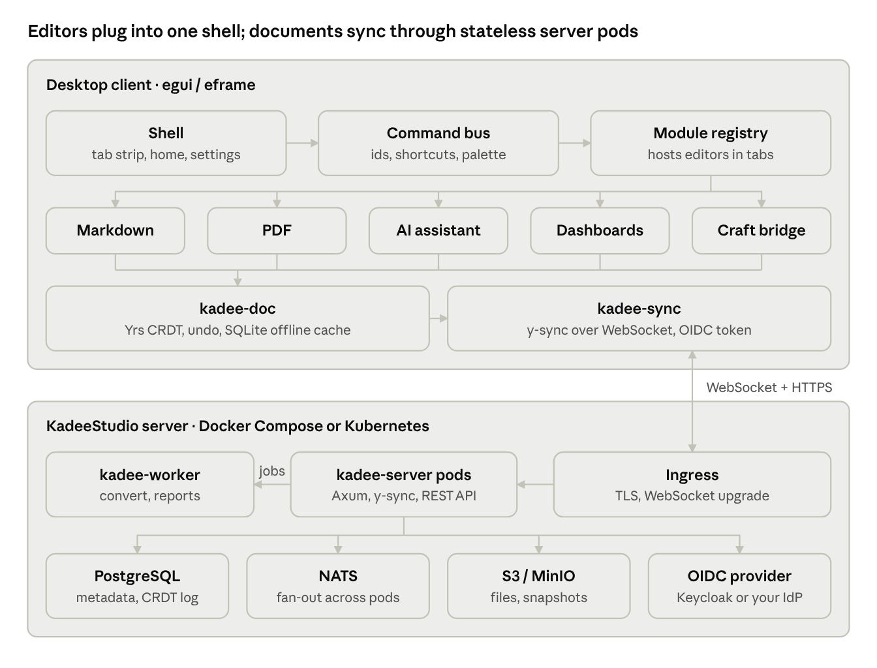
KadeeStudio architecture · client and server
The shell routes every action through the command bus to whichever module owns the tab; modules keep their documents in kadee-doc, and kadee-sync carries the changes to the server, which stores them and relays them to other pods.
Cargo workspace (the start screen ships the crates marked Phase 0):
Crate | Job | Phase
apps/kadeestudio | Desktop binary: window, tab strip, home screen, settings | 0
crates/kadee-core | Module catalogue (ModuleKind), Crafting Apps catalogue, file-type registry (which module or Crafting App opens each extension), recent/starred library, settings, home.json persistence | 0
crates/kadee-ui | Design tokens, light/dark themes, icons, shared widgets (cards, pills, file table) | 0
crates/kadee-commands | Command ids, registry, keyboard bindings, command palette | 0 (minimal)
crates/kadee-ai | Providers and models, Ask AI chat, the AI side pane, document context extraction, tool calls onto commands, MCP server | 1
crates/kadee-module-api | Module trait the shell uses to host an editor in a tab | 2
crates/kadee-doc | Yrs document wrapper, local SQLite cache, undo, awareness (cursors) | 2
crates/kadee-markdown | Markdown editor module on mdcraft-core | 2
crates/kadee-sync | Client side of the y-sync WebSocket protocol, auth tokens, offline queue | 3
server/kadee-server | Axum collaboration and API server, AI gateway for organisation-wide keys and policy | 3
crates/kadee-pdf | PDF viewer/editor module | 4
crates/kadee-convert | Format conversion pipeline (MD, PDF, HTML, DOCX, PPTX) | 5
server/kadee-worker | Background jobs: conversion, report rendering, scheduled refresh | 5
crates/kadee-data | DataFusion query engine, connectors, semantic models | 6
crates/kadee-dash | Dashboard and report designer modules | 6
crates/kadee-craft | Bridge to the Crafting Apps (ArtCraft and SolidCraft): launch, embed, file hand-off | 7
The module contract every editor implements:
pub trait Module: Send {
fn kind(&self) -> ModuleKind; // Markdown, Pdf, Dashboard …
fn title(&self) -> String; // tab label
fn ui(&mut self, ui: &mut egui::Ui, cx: &mut ShellContext);
fn commands(&self) -> &[CommandSpec]; // ribbon + palette entries
fn save(&mut self) -> Result<(), ModuleError>;
fn is_dirty(&self) -> bool;
}
Rules that keep the codebase healthy: engine crates never depend on egui (the same rule the Crafting Apps follow), so the server and CLI can reuse them; modules talk to each other only through commands and file hand-off; and every user action goes through kadee-commands, never a direct callback.

Collaboration and deployment
The same container images run on a laptop with Docker Compose, on-prem Kubernetes and managed cloud Kubernetes; only the Helm values change.
How a shared edit flows:
- The client edits its local Yrs document and stores the update in its SQLite cache, so work continues offline.
- kadee-sync sends the update over a WebSocket to any kadee-server pod (y-sync protocol, OIDC bearer token).
- The pod checks the user's role on the document, appends the update to PostgreSQL, and publishes it on a NATS subject per document.
- Every pod with clients on that document relays the update; cursors and presence travel the same way as Yrs awareness messages.
- A compaction job merges old updates into a snapshot and stores large binaries (images, PDFs, datasets) in S3-compatible storage.
Component | Image / service | Docker Compose | Kubernetes
API + sync | kadee-server (Rust, distroless) | 1 container | Deployment, HPA on connections and CPU, PodDisruptionBudget
Workers | kadee-worker | 1 container | Deployment or KEDA-scaled jobs
Metadata + CRDT log | PostgreSQL 16+ | container with volume | CloudNativePG operator on-prem; RDS / Azure Database / Cloud SQL in the cloud
Files and snapshots | MinIO or any S3 API | container with volume | MinIO operator on-prem; S3 / Azure Blob / GCS
Fan-out between pods | NATS | container | NATS Helm chart (3 replicas)
Identity | Keycloak (optional) | container | Keycloak operator, or an external IdP via OIDC
Ingress | Caddy | container with automatic TLS | ingress-nginx or Gateway API, cert-manager
Observability | OpenTelemetry → Prometheus, Grafana, Loki | optional profile | kube-prometheus-stack
Deliverables in the repo: deploy/compose/docker-compose.yml (single-node, docker compose up), deploy/helm/kadeestudio (chart with values for on-prem and cloud), and multi-arch images (amd64, arm64) published to GHCR. Access control is role-based per workspace and per document (owner, editor, commenter, viewer); audit events go to PostgreSQL.

Module roadmap
Each module ships when it can replace its office counterpart for everyday work, not when it matches every feature.
Kadee AI (Phase 1, before the editors). One assistant for the whole suite, built on SolarOffice's AI layer: provider and model settings (cloud keys or local models), an Ask AI chat in the sidebar that answers from starred or selected documents of any type in the list, and an AI pane in every file tab. The assistant acts only through commands (create, open, star, convert, summarise), so whatever it does the user can also do and undo. An MCP server exposes the same commands to Claude Code and other agents. When the server arrives, an AI gateway adds organisation keys, usage limits and audit.
Kadee Markdown (first editor, Phase 2). Port mdcraft: ribbon (Home, Insert, Design, Slides, Review, View), write / split / read modes, templates, slide decks with presenter mode, export to PDF and HTML. New in KadeeStudio: a native egui editor surface, live co-editing with cursors, comments anchored to text, and version history from the CRDT log.
Kadee PDF. View, search, annotate, fill forms, sign; organise pages (merge, split, rotate, reorder); redact; protect with passwords. Reuse the PdfCraft engine where it fits; collaborative annotations stored as a CRDT layer beside the untouched PDF.
Kadee Convert. One pipeline with a shared intermediate model: Markdown ↔ HTML, Markdown → PDF (Typst), DOCX / PPTX / XLSX → Markdown or PDF, images → PDF, OCR for scans. It has no start-screen tile: it is reached from File › Convert, the right-click menu in the document list, and the AI. Runs in the app for single files and in kadee-worker for batches.
Kadee Dashboards and Reports. Metabase-style: connect a data source, explore with a visual query builder or SQL, save questions, assemble dashboards with filters and cross-filtering, schedule refresh and e-mail delivery. Power BI-style: a semantic model (measures, relationships), paginated reports exported to PDF. Queries run in DataFusion on the desktop for files and on the server for shared databases, with row-level security.
Crafting Apps. Fourteen apps, listed alphabetically: thirteen ArtCraft apps plus SolidCraft (3D CAD, from Tangency Labs). Their file types are part of the start screen from Phase 0, so All lists every document KadeeStudio or a Crafting App can open (see the file-type table in Phase 0). Three levels of integration, in order: (1) a launcher card that installs and opens each app, like ArtCraft's craft-launcher; (2) file hand-off, so a picture in a Markdown document opens in PhotoCraft or a STEP file in SolidCraft and comes back saved; (3) embedding engine crates (vector, grid, deck) as KadeeStudio modules where their licence and APIs allow.

Phased implementation plan
Phase 0 is the start screen delivered with this plan; AI comes next (Phase 1), so every editor after it is built with the assistant in place. Phase 3 (sync server) can run in parallel with Phase 2 because the Markdown module is built on kadee-doc from day one.
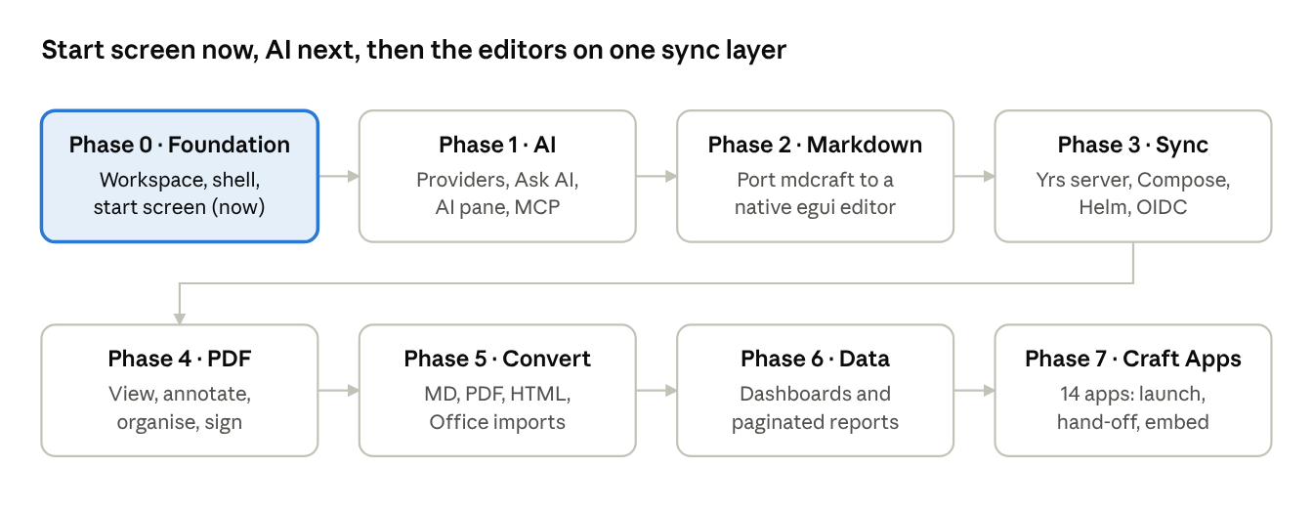
phased roadmap · 8 phases
Each phase ends with a gate: it ships when a real user can do their everyday work in that module, with tests and packaged builds for macOS, Windows and Linux.
Phase 0 — start screen (delivered now). Scope, modelled on GenOffice's home tab and your SolarOffice home screen:
- Tab strip with a Home tab, one tab per opened file, a + new-file menu and a light/dark/system theme switch
- Sidebar: Home, Recent, Starred, Crafting Apps, the KadeeStudio documents folder, Settings
- Greeting and quick-start tiles for Markdown, PDF, Dashboard and Report, plus Open file (no Convert tile)
- A Crafting Apps row with all fourteen apps in alphabetical order, SolidCraft included (cards only, marked Phase 7)
- File list: type filter pills (All, Office, Markdown, PDF, Dashboard, Report, Graphics, Media, CAD), search, sortable Name / Opened / Modified / Size, star toggle. All shows every file type that KadeeStudio or any Crafting App opens (table below); each row says which app opens it
- Settings: display name, theme, documents folder; state saved to home.json in the config folder (KADEE_CONFIG_DIR overrides)
- A file tab shows the file's details, the app that will open it, and an Open in default app button until the editors exist
- No AI, no editors, no server
Phase 0 is done when cargo run -p kadeestudio opens the start screen on all three desktops, cargo test passes for kadee-core, and cargo clippy is clean.
Document types on the start screen (one registry in kadee-core; the first matching row wins, so PDF opens in Kadee PDF rather than PdfCraft):
Filter pill | Extensions | Opens in
Office | .pptx | DeckCraft
Office | .xlsx .csv | GridCraft
Office | .docx | WordCraft
Markdown | .md .markdown .mdd .mds | Kadee Markdown
PDF | .pdf | Kadee PDF
Dashboard | .kdash | Kadee Dashboards
Report | .kreport | Kadee Reports
Graphics | .designcraft | DesignCraft
Graphics | .figcraft .fig | FigCraft
Graphics | .psd .png .jpg .jpeg .webp .tif .tiff | PhotoCraft
Graphics | .svg .eps .emf .wmf .vectorcraft | VectorCraft
Media | .effectcraft | EffectCraft
Media | .mp4 .mov .mkv .webm | FilmCraft
Media | .dng .cr2 .cr3 .nef .arw .raf .orf .rw2 | LightCraft
Media | .wav .aif .aiff .flac .mp3 .ogg .m4a .caf .mid .midi | SoundCraft
CAD | .dwg .dxf | CadCraft
CAD | .step .stp .iges .igs .3mf .stl .obj .gltf .glb | SolidCraft
The .designcraft and .effectcraft project extensions follow VectorCraft's .vectorcraft pattern and still need confirming against those apps; the list is checked against each app's documentation before Phase 7.
Phase 1 — AI. Scope:
- Settings › AI providers (add, test connection, local servers without a key) and AI models (a default plus one per module); API keys in the OS keychain
- Ask AI in the sidebar: a streaming chat that can use starred or selected documents; text is extracted from Markdown, PDF and Office files; token and cost footer, Stop, Clear
- An AI pane in every file tab, scoped to that file
- Tools are commands: the assistant can search, open, create, star and summarise documents; anything that writes or deletes asks first
- An MCP server (kadeestudio mcp) exposing the same commands to agents
Phase 1 is done when Ask AI answers from a starred PDF and a Markdown file with both a cloud model and a local model, and every action the assistant takes appears in the command log.

Risks and open decisions
Risk | Impact | Mitigation
AI arrives before the editors, so it has little to act on | Phase 1 feels thin | Scope it to what exists: Ask AI over documents of every type, summaries, search, creating and organising files; the editor tools plug in as each module ships
Documents sent to cloud AI providers | Data leaves the organisation | Local models via Ollama or an on-prem OpenAI-compatible server; per-workspace provider policy; the server's AI gateway logs every call
A rich Markdown editor in pure egui is a large build | Phase 2 slips | Start with egui's multiline editor plus syntax colouring; keep the wry preview pane behind a feature flag; move to a cosmic-text surface once it is stable
Mermaid, Vega, Plotly have no Rust renderers | Some mdcraft previews missing natively | Keep them in the optional webview pane; render the common subset natively; Typst for math
CRDT history grows without bound | Slow loads, large database | Snapshot and compaction job; keep N days of fine-grained history
Office-format fidelity (DOCX, PPTX) | Conversion complaints | Convert to Markdown/PDF only at first; borrow WordCraft, DeckCraft and GridCraft parsers later
Crafting Apps (ArtCraft and SolidCraft) evolve independently | Embedded crates break; file-type list drifts | Pin versions; start with launch and file hand-off, embed only stable engine crates; re-check the file-type registry each release
Dashboards scope creep toward full Power BI | Phase 6 never ends | Ship Metabase parity first (questions, dashboards, filters, schedules), then semantic models
Open decisions for you:
- ☐ Confirm egui/eframe over Dioxus (SolarOffice) for the shell
- ☐ Licence for KadeeStudio itself (MIT OR Apache-2.0 matches mdcraft and the Crafting Apps)
- ☐ Identity provider for on-prem: bundled Keycloak or customer IdP only
- ☐ AI providers to support at launch, and whether a local model is the default
- ☐ Repository name and GitHub location (for example kdugardyn66/kadeestudio)

Sources
- mdcraft repository
- SolarOffice repository
- GenOffice repository
- ArtCraft craft-launcher
- VectorCraft (egui frontend in its own crate)
- SolidCraft and an overview of it

